A

Mini-Project Report on

## BusYatra

Submitted in partial fulfillment of the requirements for the degree of

BACHELOR OF ENGINEERING

IN

### Computer Science & Engineering

### Artificial Intelligence & Machine Learning

by

Sumant Bhise (22106095)

Mithil Bhosale (22106134)

Sumedh Gadpayle (22106076)

Tejas Joshi (22106018)

Under the guidance of

## Prof. Taruna Sharma



### Department of Computer Science & Engineering

### (Artificial Intelligence & Machine Learning)

**A. P. Shah Institute of Technology, G. B. Road, Kasarvadavali, Thane (W)-400615**

**University Of Mumbai**

**2023-2024**

## 

## A. P. SHAH INSTITUTE OF TECHNOLOGY

## CERTIFICATE

This is to certify that the project entitled “**BusYatra”** is a bonafide work of Sumant Bhise (22106095), Mithil Bhosale (22106134), Sumedh Gadpayle (22106076), Tejas Joshi (22106018) submitted to the University of Mumbai in partial fulfillment of the requirement for the award of **Bachelor of Engineering** in **Computer Science & Engineering (Artificial Intelligence & Machine Learning).**

|  |  |
| --- | --- |
| ________________ | _______________ |
| Prof. Vijayabharathi | Dr. Jaya Gupta |
| Mini Project Guide | Head of Department |

## 

## A. P. SHAH INSTITUTE OF TECHNOLOGY

## Project Report Approval

This Mini project report entitled “**BusYatra*”*** by **Sumant Bhise, Mithil Bhosale, Sumedh Gadpayle and Tejas Joshi**is approved for the degree of ***Bachelor of Engineering*** in ***Computer Science &Engineering***, (AIML) ***2022-23***.

##### External Examiner:

##### Internal Examiner:

Place: APSIT, Thane

Date: 02/11/2023

**Declaration**

##### We declare that this written submission represents my ideas in my own words and where others' ideas or words have been included, I have adequately cited and referenced the original sources. I also declare that I have adhered to all principles of academic honesty and integrity and have not misrepresented or fabricated or falsified any idea/data/fact/source in my submission. I understand that any violation of the above will be cause for disciplinary action by the Institute and can also evoke penal action from the sources which have thus not been properly cited or from whom proper permission has not been taken when needed.

|  |  |  |  |
| --- | --- | --- | --- |
| Sumant Bhise | Mithil Bhosale | Sumedh Gadpayle | Tejas Joshi |
| (22106095) | (22106134) | (22106076) | (22106018) |

**ABSTRACT**

The proposed system provides a user-friendly and efficient bus ticket booking system. Real time information about seat availability is provided on different bus routes to help users make easy and informed decisions. Bus passes can be assigned to needful customers.

Programming Languages Used:

1. Java script
2. Mongo DB
3. Node JS
4. MYSQL
5. React JS

* Users can first create accounts by signing up and then logging in.
* Users can book tickets for intercity travel by selecting the starting and destination points.
* Users can select the time and date of their travel.
* Users can apply for bus passes by entering the required details.
* Credits are gained through consistent travelling. Users can redeem these credits in exchange for money.
* Buses can be tracked in real time.
* Availability of seats can be tracked in real time.

**Index**

|  |  |  |  |
| --- | --- | --- | --- |
| Index | | | Page no. |
| Chapter-1 | | |  |
|  | Introduction | |  |
|  |  |  |  |
| Chapter-2 | | |  |
|  | Literature Survey | |  |
|  | 2.1 | History |  |
|  | 2.1 | Review |  |
|  |  |  |  |
| Chapter-3 | | |  |
|  | Problem Statement | |  |
|  |  |  |  |
| Chapter-4 | | |  |
|  | Experimental Setup | |  |
|  | 4.1 | Hardware setup |  |
|  | 4.2 | Software Setup |  |
|  |  |  |  |
| Chapter-5 | | |  |
|  | Proposed system and Implementation | |  |
|  | 5.1 | Block Diagram of proposed system |  |
|  | 5.2 | Description of Block diagram |  |
|  | 5.3 | Implementation |  |
|  |  |  |  |
| Chapter-6 | | |  |
|  | Conclusion | |  |
|  |  |  |  |
| References | | |  |
|  |  |  |  |

# CHAPTER 1

# INTRODUCTION

### INTRODUCTION

A bus reservation system is a mobile or web software solution designed to provide customers with a personalized easy-to-utilize user experience for booking and purchasing tickets online. It stores customers’ personal data records, scheduled routes, frequent trips, drop points, and other information.

You can implement real-time seat availability, multiple payment gateways, offer seat map functionality, and other features. A transport booking eliminates human factor risks and improves conversion rates for your business.

The bus reservation system benefits one can get are:

1. High automation of bus ticket booking

Millions of people book bus tickets daily to reach their destination points like office, school, college, shopping centers, hospitals, etc. The large volumes of incoming requests definitely take lots of time to process and confirm by phone.

Bus ticket booking and reservation allows you to fully automate the bus ticket booking process and facilitate hundreds of bookings daily.

This way, automation enables you to reduce customer service costs gradually as you just need to set up autoreply emails and adjust technical aspects to send tickets to customers.

2. 24/7 availability for customers

The Forrester research states that almost 80% of customers would prefer companies that offer 24/7 service with an effortless and transparent process.

Online bus ticket reservation system is about full availability which means that customers can reserve and buy tickets whenever they want. It means that clients can avoid contacting sales reps and purchase bus seats through a mobile/desktop application in a contact-free manner.

This greatly benefits your business as you don’t have any downtimes when your bus reservation system is unavailable for customers.

So, a bus seat booking system allows you to boost sales and focus on more strategically important and major tasks like promotional activities, product improvement, and expansion into the new markets.

3. Instant and contact-free payments

According to the PR Newswire report 2021, the global payment processing solutions market is expected to reach over $52 billion by 2026 at a CAGR of 6% during the 2021-2026 period.

By way of contrast, in 2019 the global payment solutions market size was at the level of $33 billion.

These statistics mean that online payment processing products are gaining momentum and covering the key needs of most digital businesses.

In the case of online bus ticket reservation software, payment solutions are a must-have feature that allows customers to perform instant and contact-free purchases through the Internet. Everything you need is to establish a legal entity (if needed) and create a banking account that will accept payments from customers

# CHAPTER 2

# LITERATURE SURVEY

#### 1. LITERATURE SURVEY

###### 2.1-HISTORY

Online Booking:

* The advent of the internet in the late 20th century brought about a significant transformation in bus ticket booking systems.
* Bus companies started offering online booking platforms that allowed passengers to browse schedules, select seats, and make payments through websites and mobile apps.
* Online booking made it convenient for passengers to book tickets from the comfort of their homes or on the go.

Mobile Ticketing:

* With the proliferation of smartphones, mobile ticketing apps became popular. Passengers could book and store electronic tickets on their mobile devices.
* Mobile ticketing apps often provide real-time updates on bus schedules and enable contactless ticket validation.

Integration with Travel Aggregators:

* Many bus operators integrated their booking systems with travel aggregator websites and apps, allowing passengers to compare prices and schedules across multiple bus companies in one place.

Digital Payment Solutions:

* Modern bus ticket booking systems offer a variety of digital payment options, including credit cards, debit cards, mobile wallets, and online banking, making it easier for passengers to pay for their tickets.

#### 2.2-LITERATURE REVIEW

**Online Bus Monitoring and Reservation Application (OBMRA) for GL Trans Agency,** Eric A. Paloy, Jayhan C. Sarne, Joseph Christian C. Padin, Mathew Jun P. Mariani.

GL Transit agencies, a privately owned domestic transportation firm desired the development of an internet application where the details of bookings and customers are regularly updated and where one can immediately track the details of available seats. They also wanted to get rid of the tedious manual system where people would have to wait in line for hours to obtain bus tickets, whilst being forced to pay in cash.

**Development of an Online Bus Ticket Reservation System for a Transportation Service in Nigeria** by University of Pretoria, University of Ilorin

The use of bus traveling is a large growing business in Nigeria and other countries; the manual use of bus reservation was very strenuous and also consumed a lot of time by having to succumb to processes. For this reason, an efficient system was proposed in this paper to ease the issue of bus reservation amongst indigenes within the country.

**Global Journal of Engineering Sciences and Researches, Bus Reservation System,** K. Laxmi Sai Prasanna, K. Shivani, N. Vaishnavi, Ms.P R Anisha, Dr. B V Ramana Murthy & Mr. C Kishor Kumar Reddy.

Public transportation has been classified as an essential mode of travelling. In older days, human travels from one location to another takes months and years, with less support of technology and communication tools. Currently, with the effective and efficient mode of transportation, one could travel thousands of miles with hours and days and communicate across the globe within split of seconds. Public in many countries, especially in the third world, prefer to use buses and train services to travel from one location to another. “Electronic ticketing system is the ticketing system which uses self-service technology as a base of application helping the user to book a ticket by themselves”

**Modern Coast Bus Ticket Booking System**, by Edward Koigi

The system is web-based application where users gain access to the available buses per a certain route and available seats by logging in through the customer’s portal.

The staff will access to the system by logging in via the staff portal where they can compare bus performances and monitor other related business performance issues.

# CHAPTER 3

# Problem Statement

#### Problem Statement

The existing bus booking process in our region is fraught with numerous challenges and inconveniences for both passengers and bus operators. These issues include:

1. Inefficient Booking Processes: The current system relies heavily on manual ticketing processes, leading to long queues at ticket counters and considerable time wastage for passengers. This inefficiency often results in frustration and dissatisfaction among travelers.
2. Limited Accessibility: Many passengers face difficulties in accessing bus services and booking tickets due to the lack of user-friendly online platforms. This restricts the reach of bus services and limits the potential for increased ridership.
3. Lack of Real-Time Information: Passengers often lack access to real-time information about bus schedules, seat availability, and route updates. This uncertainty can lead to missed connections and inconvenient travel experiences.

# CHAPTER 4

# Experimental Setup

**HARDWARE SETUP**

**Computer**: A modern Windows PC or laptop with at least a dual-core processor.

**Memory (RAM)**: A minimum of 4GB of RAM is recommended for smooth development and testing, but 8GB or more is better for larger-scale applications.

**Storage**: You'll need sufficient storage space for your development tools, libraries, and datasets. At least 100MB of free storage space is recommended.

**SOFTWARE SETUP**

**1. Operating System:** This web application is made on windows / ios / linux operating system.

**2. Web Development Tools:** Text Editor or Integrated Development Environment (IDE). We have use tools like Visual Studio Code.

**3. How API works :** Weather APIs work by providing a standardized way for applications to access and retrieve weather data from external sources. These APIs are typically offered by meteorological services, weather data providers . When a weather application, website, or service needs weather information for a specific location, it sends a request to the weather API, often including parameters like location coordinates, date, and specific weather data required, such as current conditions, forecasts, or historical data. The API processes the request, which may include complex calculations and data retrieval, and responds with the requested weather information, usually in a structured format like JSON or XML. The weather application then parses and formats this data for presentation to the end user. Weather APIs can also provide additional features like geolocation-based services, severe weather alerts, and historical weather data, making them invaluable for a wide range of applications, from mobile weather apps to smart home automation systems. These APIs help developers integrate accurate and up-to-date weather information seamlessly into their applications, enhancing user experience and functionality.

**4. Programming Languages and Frameworks:**

**\* Backend:** The programming language and framework: JavaScript

**\* Frontend:** HTML, CSS, and JavaScript are used for the user interface to make the frontend more attractive.

**Chapter 5**

**Proposed System & Implementation**

**Proposed system & Implementation**

* **Block diagram of proposed system**

**Implementation**

* **Choose Buses**

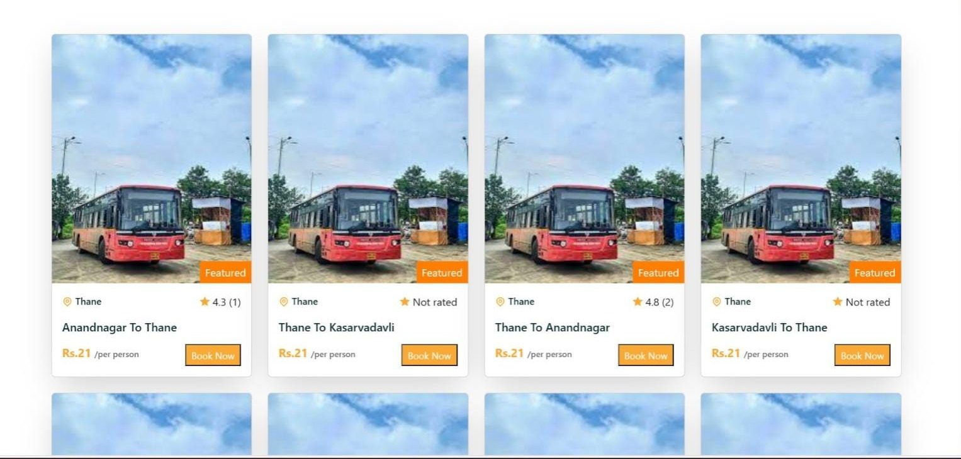

# Select Pickup location and Drop location

# 

# Reviews

# 

# CHAPTER 6

# CONCLUSION

# Conclusion

# In conclusion, the advent of online bus ticket booking systems has revolutionized the way people plan and manage their travel. This technology-driven solution offers convenience, efficiency, and numerous benefits to both passengers and bus operators. With just a few clicks, travelers can easily browse bus schedules, select preferred seats, and secure their tickets from the comfort of their homes or mobile devices. Online bus ticket booking systems have significantly reduced the hassle of long queues and uncertainty associated with traditional ticketing methods. They have also improved the overall travel experience by providing real-time information, allowing for better planning, and promoting transparency. Moreover, these systems have empowered bus companies to streamline their operations, manage resources more effectively, and expand their reach to a wider audience. As technology continues to evolve, online bus ticket booking systems are expected to play an even more significant role in enhancing the way we travel and ensuring a smoother and more enjoyable journey for passengers.

**References**

* [**https://www.researchgate.net/publication/326468848_Online_Bus_Ticket_Reservation_System**](https://www.researchgate.net/publication/326468848_Online_Bus_Ticket_Reservation_System)
* **chrome-extension://efaidnbmnnnibpcajpcglclefindmkaj/https://core.ac.uk/download/pdf/234644905.pdf (Nigeria)**
* [**https://www.academia.edu/40839070/BUS_TICKET_RESERVATION_SYSTEM**](https://www.academia.edu/40839070/BUS_TICKET_RESERVATION_SYSTEM)
* **extension://efaidnbmnnnibpcajpcglclefindmkaj/https://www.gjesr.com/Issues%20PDF/ICITAIC-2019/31.pdf**
* **extension://efaidnbmnnnibpcajpcglclefindmkaj/https://ijels.com/upload_document/issue_files/58IJELS-101202340-OnlineBus.pdf**